Waterloo Engineering Society

Board of Directors Meeting June 2018

Date: June 11th, 2018
Chair: Matthew Suski
Secretary: Laura Scanlan

Title | Receipt of Auditors’ Report
Mover | Katie Arnold
Seconder | Liam Yeates
Spirit | To receive the auditor’s report of the 2017 fiscal year
WHEREAS | MNP, on behalf of the Federation of Students, performed an audit of the Society’s finances for the 2017 fiscal year
BIRT | The auditor’s report for the 2017 fiscal year be received and ratified
Against
Abstentions
Result | Passed to JAGM

Title | Engineering Society Fee Increase
Mover | Katie Arnold
Seconder | Liam Yeates
Spirit | To increase the Engineering Society Fee as per inflation
WHEREAS | Over the 2017 calendar year, the Consumer Price Index (CPI) increased by 1.6%
AND WHEREAS | The Engineering Society Fee should be increased by CPI to allow for equal buying power from year to year
AND WHEREAS | On June 11th 2018 the Engineering Society Board of Directors approved a special resolution for an increase in the Engineering Society fee by approximately 1.6%.
BIRT | The Engineering Society Fee be increased by 25 cents from $16.15 to $16.40
BIFRT | Bylaw 1: Constitution, Chapter II: Membership and Fees, Section C: Fees, be amended to read the following:  Section C: Fees  - The amount of the Engineering Society Fee sixteen dollars and fifteen cents ($16.15) sixteen dollars and forty cents ($16.40) Canadian.  - The amount of the Engineering Society Fee may be adjusted only through one of the following two mechanisms:  - By a Special Resolution of the Board of Directors, specifying an adjustment of a percentage equal to or less than the increase in the Consumer Price Index for Canada in the previous calendar year according to Statistics Canada. This increase is subject to Ratification at the next Joint Annual General Meeting; and  - By a successful Joint Referendum specifying the amount the fee will be increased.
BIFRT | The Executive provide all required items to the University of Waterloo Board of Governors to start the process of the fee increase.
Against
Abstentions
Result | Passed to JAGM

Title | EngSoc loves student teams! [Raising the Sponsorship Cap]
Mover | Michelle Teplitski
Seconder | Michael Beauchemin
Spirit | Engineering Student Design teams are a core part of the Engineering experience for many at the University of Waterloo
WHEREAS | The Engineering Society is the representative body for all students of the faculty
AND WHEREAS | The number of students increases annually but the maximum sponsorship allocation amount within the budget remains fixed.
BIRT: | The Policy Manual be amended to reflect a 10% increase (rounded up to the nearest multiple of $500) in maximum allocation amount within the budget, as follows:  Chapter I, Section B:  Purpose  - The purpose of the Sponsorship Program is to support University of Waterloo student teams and groups.  - The Engineering Society Fee shall be allocated from the budget each term for Sponsorship as follows (in accordance with Chapter I Sections B.1 through B.4  - Fifteen percent (15%) in the Fall Term, not to exceed ten thousand dollars ($10000) eleven thousand dollars ($11000) Canadian;  - Fifteen percent (15%) in the Winter Term, not to exceed six thousand five hundred dollars ($6500) seven thousand five hundred dollars ($7500) Canadian; and  - Fifteen percent (15%) in the Spring Term, not to exceed five thousand dollars ($5000) five thousand five hundred dollars ($5500) Canadian.
Against
Abstentions
Result | Passed to JAGM

Title | Orientation Week Stance
Mover | Benjamin Beelen
Seconder
Spirit | Orientation week is where many students make their first friends (FYO report 2). Its length, position and support are in question from the enacting of the Fall Reading Break and it needs to be apparent to faculty that engineering students value orientation week.
WHEREAS | The Student Success Office conducted several “consultations” and data gathering which produced data that is unavailable to students. This information being presented to the Fall Breaking Steering Committee was unacceptably poor and the option of restoring Orientation week to five days was ignored.
AND WHEREAS | The spirit of the referendum that passed in 2015 to allow the trial of the three day Orientation week expected the evaluation of the effect it would have on student success and performance as well as mental health.
AND WHEREAS | The Engineering First Year Office has produced two reports that prove that the Fall Reading Break does not inherently promote mental health, and that first years find the majority of their friends in Orientation Week.
BIRT | The following stance be added to the Document of Stances:  “The University of Waterloo and Faculty of Engineering should strive to collect more conclusive evidence of the benefits of the Fall Reading Break before permanently enacting it at the cost of any Orientation Week days (below five days).”
Against
Abstentions
Result | Passed to JAGM

Motion: | Please Stop Hurting Us [Dean's List Alternate System]
Mover | Mariko Shimoda
Seconder | Matthew Suski
Spirit | To reduce the amount of ‘unnecessary competition’ in the Engineering student community by modifying the current Term Dean’s Honour List placement system.
Whereas | Placement on the Term Dean’s Honour List is currently determined with the formula: Term Average − (Rank / Cohort Size) ∗ 100% ≥ 80%
And Whereas | Every other faculty at the University of Waterloo determined entry on a flat mark;
And Whereas | Recognition of a student’s academic excellence should not be contingent on the academic excellence of other students;
BIRT | The Engineering Society formally adopt a stance advocating for the replacement of the current Term Dean’s Honour List placement system with an alternative system;
BIFRT | The Engineering Society President write an open letter to the Dean of Engineering advocating for the replacement of the current Term Dean’s Honour List placement system with an alternative system.
BIFFRT | The following stance be added to the Document of Stances:  “The Dean’s Office of the Faculty of Engineering should strive to reduce unnecessary competition created by the current Dean’s Honour List system, and use an alternative method to determine those on the Dean’s Honour List..”
Against
Abstentions
Result | Passed to JAGM

Title | It’s 20GAYteen Y’all [UWaterloo EngiQueers Affiliate]
Mover | Lindsay Glofcheskie
Seconder | Julia Reinstein
Spirit | The Society wants to be better at inclusivity, diversity, and equity;
WHEREAS | The Society makes a commitment to promoting diversity in its Policy Manual;
AND WHEREAS | UWaterloo EngiQueers specializes in that;
AND WHEREAS | UWaterloo EngiQueers is better suited to being an affiliate of the Society
BIRT: | The Policy Manual, Chapter II: Other Policies be amended as follows:  Section B: UWaterloo EngiQueers  - General  - UWaterloo EngiQueers is now and will continue to be a Society organization  - UWaterloo EngiQueers shall act as the official Waterloo Engineering Society representative to EngiQueers Canada.  - UWaterloo EngiQueers operates in accordance to the UWaterloo EngiQueers Constitution, an official Society document controlled by the UWaterloo EngiQueers Advisory Board and is accountable to the Society membership  - UWaterloo EngiQueers Advisory Board  - The Executive Officers of each Society shall represent their Society and sit on the UWaterloo EngiQueers Advisory Board in accordance with the UWaterloo EngiQueers Constitution  - Finances  - UWaterloo EngiQueers will request funding from the On-Term VP Finance  - The On-Term VP Finance will manage all Finances of UWaterloo EngiQueers through the termly budget  - If UWaterloo EngiQueers requests financial assistance from the Society, it shall not be reasonably refused.  - UWaterloo EngiQueers will operate as a not-for-profit organization  - The financials of UWaterloo EngiQueers including funds raised and donations shall be managed through the termly Society budget by the on-term VP Finance
BIFRT: | Following sections be renumbered accordingly
Against
Abstentions
Result | Passed to JAGM

Title | Too Many Cooks! [Board of Directors Limitation for Executive Officers]
Mover | Michael Beauchemin
Seconder
Spirit | To increase and ensure diversity in student representation on the Board of Directors (Board)
WHEREAS | Members on the same executive team often present a similar view
AND WHEREAS | Four (4) Executive Officers are already represented on Board (the two (2) Society Presidents and the two (2) Society VPs Finance hold ex-officio positions on Board)
AND WHEREAS | Executive Officers not sitting on Board may submit motions for discussion through either President, per procedure
BIRT | Bylaw 1: The Constitution, Chapter V, Section C, be appended with the following items:  ...  7. If a Director graduates during their term of office, they shall remain in their position on the Board until their term of office is complete.  8. No Executive Officer, save the Presidents and Vice-Presidents Finance, may hold a position on the Board.  9. If a Director is elected to any Executive Officer position, they shall lose their current position at the beginning of the term immediately following the election, and the Board may appoint a new Director per Section L.
Against
Abstentions
Result | Passed to JAGM

Title | [Board of Directors Restructure]
Mover | Michael Beauchemin
Seconder
Spirit | To reorganize the Engineering Society Board of Directors to increase the representation present on the Board
WHEREAS | The current Board of Directors’ structure and election process draws on a limited pool of persons for the election.
AND WHEREAS | Members who are present at JAGM represent a limited interest.
AND WHEREAS | The elected Federation of Students’ Council’s Engineering Councillors are exposed to a different variety of views and information to EngSoc Council Reps and
BIRT | Bylaw 1: The Constitution, Chapter V be amended to read as follows:  Section A: General  1. The business and affairs of the Society shall be managed overseen by a Board of Directors.  Section B: Board of Directors  1. The Board shall be comprised of all:  a. The two (2) Presidents of the Society;  b. Four (4) Two (2) Representatives from the A-Society Membership;  c. Four (4) Two (2) Representatives from the B-Society Membership;  d. Three (3) Representatives elected from the Engineering Councillors  e. The two (2) Vice-Presidents Finance, who will sit as ex-officio members; and  f. The Business Manager of the Society, who will sit as an ex-officio non-voting resource member.  Section C: Elections and Term of Office  1. The Directors, other than the Presidents, Vice-Presidents Finance, and the Business Manager, will be elected at the Joint Annual General Meeting.  2. The A-Society Representatives will be elected by the A-Society Members.  3. The B-Society Representatives will be elected by the B-Society Members.  4. The Engineering Councillor Representatives will be elected by joint membership of A- and B-Societies  5. The term of office for each Director shall start September 1 of the year they are elected.  6. The term of office for each Director shall last twelve (12) months.  7. No Director may hold two voting positions on the Board.  8. If a Director graduates during their term of office, they shall remain in their position on the Board until their term of office is complete.  Section K: Recall  1. Any Director, other than the Presidents and the Vice-Presidents Finance, may be recalled by Resolution of a General Meeting called to that end.  a. A-Society Representatives may only be removed by the A-Society Membership.  b. B-Society Representatives may only be removed by the B-Society Membership.  c. Engineering Councillor Representatives may be removed by joint decision of the A- and B-Society Memberships  2. Any Director that has two unexcused absences may be recalled from the Board following the second occurrence.  Section L: Vacancy  1. In the event of a vacancy among the elected Directors, including due to the failure of the Joint Annual General Meeting to elect all Directors, the Board of Directors may appoint a replacement from the A-Society Membership, or the B-Society Membership, or the Engineering Councillors, as applicable.  2. A Board Member elected to fill a vacancy holds the same term of office as the rest of the Board of Directors.
Against
Abstentions
Result | Passed to JAGM

Title | If You Don't Pay Your Fees You Can't Govern [Board of Directors Recall for taking back your fees]
Mover | Michael Beauchemin
Seconder
Spirit | To ensure Directors sitting on the Board of Directors always represent the student voice.
WHEREAS | Directors who refund their EngSoc fee or switch out of Engineering would still be allowed to serve on the Board.
BIRT | Bylaw 1: The Constitution, Chapter V, Section C, be appended with the following:  ...  7. If a Director graduates during their term of office, they shall remain in their position on the Board until their term of office is complete.  8. If a Director ceases to be a member of either Engineering Society, they may be recalled by decision of the Presidents and the Vice-Presidents Finance.
Against
Abstentions
Result | Passed to JAGM

Title | Let them vote! [VPs Finance on the Board of Directors]
Mover | Michael Beauchemin
Seconder
Spirit | To give the VPs Finance a vote on the Board of Directors
WHEREAS | The VPs Finance have a unique and often insightful view on many matters
AND WHEREAS | The VPs Finance do not currently have a vote
BIRT | Bylaw 1: The Constitution, Chapter V, Section B be amended to read as follows:  Section B: Board of Directors  1. The Board shall be comprised of all:  a. The two (2) Presidents of the Society, who will sit as ex-officio members;  b. Four (4) Representatives from the A-Society Membership;  c. Four (4) Representatives from the B-Society Membership;  d. The two (2) Vice-Presidents Finance, who will sit as ex-officio non-voting resource members; and  e. The Business Manager of the Society, who will sit as an ex-officio non-voting resource member.
Against
Abstentions
Result | Passed to JAGM

Title | [Switching Societies as a Director for the Board of Directors]
Mover | Michael Beauchemin
Seconder
Spirit | To ensure fair and equal representation of both Societies on the Board of Directors (Board)
WHEREAS | Some students switch streams other than at the beginning or end of their respective programs
AND WHEREAS | Such a stream switch can result in unequal representation within each Society’s At-Large membership on Board
BIRT | Bylaw 1: The Constitution, Chapter V be amended to read as follows:  Section A: Board of Directors  1. The Board shall be comprised of all:  a. The two (2) Presidents of the Society;  b. Two (2) A-Society Representatives from the A-Society Membership;  c. Two (2) B-Society Representatives from the B-Society Membership;  d. Three (3) Representatives elected from the Engineering Councillors  e. The two (2) Vice-Presidents Finance, who will sit as ex-officio non-voting resource members; and  f. The Business Manager of the Society, who will sit as an ex-officio non-voting resource member.  Section C: Elections and Term of Office  1. The Directors, other than the Presidents, will be elected at the Joint Annual General Meeting.  2. The A-Society Representatives will be elected by the A-Society Members.  3. Each A-Society Representative must be an A-Society Member for at least eight (8) of the following twelve (12) months.  4. The B-Society Representatives will be elected by the B-Society Members.  5. Each B-Society Representative must be a B-Society Member for at least eight (8) of the following twelve (12) months.  6. The term of office for each Director shall start September 1 of the year they are elected.  7. The term of office for each Director shall last twelve (12) months.  8. No Director may hold two voting positions on the Board.  9. If a Director graduates during their term of office, they shall remain in their position on the Board until their term of office is complete.  10. If a Director fails to meet the conditions for 3. or 5. above, they may be subject to recall, by simple majority of the Board
Against
Abstentions
Result | Passed to JAGM

Title | New Kids An Town [A-Soc Board]
Mover | Mariko Shimoda
Seconder | Katie Arnold
Spirit | To elect new A-Society Board Members for the 2018-2019 year
WHEREAS | As of September 1st, 2018, there will be 4 vacant at-large seats for the A-Society membership.
AND WHEREAS | It is the responsibility of the Joint Annual General Meeting to elect new Board Members
BIRT | The following four members be elected to fill the at-large A-Society seats for the Board of Directors:  1. _________________________  2. _________________________  3. _________________________  4. _________________________
Against
Abstentions
Result | Passed to JAGM

Title | New Kids Bn Town [B-Soc Board]
Mover | Katie Arnold
Seconder | Mariko Shimoda
Spirit | To elect new B-Society Board Members for the 2018-2019 year
WHEREAS | As of September 1st, 2018, there will be 4 vacant at-large seats for the B-Society membership.
AND WHEREAS | It is the responsibility of the Joint Annual General Meeting to elect new Board Members
BIRT | The following four members be elected to fill the at-large B-Society seats for the Board of Directors:  1. _________________________  2. _________________________  3. _________________________  4. _________________________
Against
Abstentions
Result | Passed to JAGM

Title | Proof We’ve Improved [Ratifying Changes to the Governing Docs]
Mover | Katie Arnold
Seconder | Mariko Shimoda
Spirit | To ratify all changes to the governing documents that have been made since Joint Annual General Meeting 2017
WHEREAS | Numerous changes to the bylaws and policy manual were passed by the A-Society and B-Society councils in the previous year
AND WHEREAS | It is best practice to have these changes passed by general members at the Joint Annual General Meeting
AND WHEREAS | The following motions be ratified:  - Mr. Speaker, We’re Amending the Constitution!  - Now This is Just Ridiculous  - Bye Felicia  - Just So We’re Clear
Against
Abstentions
Result | Passed to JAGM

Title | Let’s tell awesome people they are awesome [Adoption of the “Friend of the Society” Award]
Mover | Awn Duqoum
Seconder
Spirit | Faculty and Staff who go out of their way to support the mental health of students deserve recognition
WHEREAS | Student mental health is negatively affected by the high stress environment created by the nature of the degree we are all pursuing
AND WHEREAS | As a class, we Tron 19, acknowledge and admit that tragedies that occurred during the winter 2018 term have also taken a toll on our moral and mental well being
AND WHEREAS | During our time here, we Tron 19, have had the privilege and honor to work with extraordinary faculty and staff member who went of their way to support us and other students
AND WHEREAS | It is important for EngSoc to recognize the efforts made by these faculty and staff members
AND WHEREAS | A-Society council has elected to award 3 deserving faculty and staff members the honorary title of “Friend of the Society” in the winter 2018 term
BIRT: | The Policy Manual be amended to include the following:  Section I: Friend of the Society Award Policy  - Purpose  - The purpose of the Friend of the Society Award, hereinafter called the Award, is to promote and reward Faculty and Staff Members who have gone out of their way to support the mental health of students  - Each term, the Engineering Society will recognize Faculty and Staff Members who have gone above and beyond to support the mental health of students. The Faculty and Staff Members who win this award have gone out of their way to exemplify one (1) or more of the following criteria:  - Advocated on behalf of students to eliminate elements that have a negative effects of student mental health;  - Showing a long-term commitment and vested interest to the betterment of student mental health; and/or  - Taking action to directly improve the mental health of students;  - Eligibility  - Any Faculty or Staff member in the Faculty of Engineering, including the School of Architecture, shall be eligible for this Award.  - The only exceptions are those who have won the Award in the previous three (3) years.  - The Friend of the Society Award Selection Committee  - The recipient of the Award shall be decided by the Friend of the Society Award Selection Committee, hereinafter called the Committee.  - The Committee s composed of five (5) members, each receiving exactly one (1) vote:  - The On-Term Vice-President Academic, who will act as Chair;  - The Off-Term Vice-President Academic, or a designate;  - Three (3) At-Large Student Members of the On-Term Society (in accordance with Chapter II Section I.3.c).  - The At-Large Student Members shall be chosen by their Society at the first Meeting of Council each term  - The shall be appointed by their Council, and serve until the end of the Academic Term in which they are elected; and  - In the event of vacancy, a new At-Large Student Member shall be appointed at the following Meeting of Council  - The responsibilities of the At-Large Student Members, with assistance from the On-Term Vice-President Academic, are as follows:  - Ensure all operations of the Committee and Award occur in accordance with this Policy;  - Soliciting for and receiving all nominations. All efforts should be made each term to receive a minimum of five (5) nominations from a variety of disciplines;  - In the event that five (5) nominations are not received, the At-Large Student Members are to bring forward additional Candidates based on their consultations with students.  - Upon selection of a winner, the At-Large Student Members shall work with the On-Term Vice-President Academic in the following manners:  - Coordinating and obtaining support letters from students to be included in nomination packages for other applicable teaching awards,  - Working with the Iron Warrior to publish an article recognizing the winner;  - Working with the EngSoc Website team to update the list of award winners to include the name of the recipient;  - Ensuring the Award plaque is updated with the winner’s name; and  - Ensuring the nominations are circulated to Committee Members no later than one (1) week prior to voting.  - The responsibilities of the Committee are as follows:  - The Committee shall meet once per Academic Term to review applications to the Award; and  - Upon reviewing the applications to the Award, the Committee shall determine the recipient with a four fifths (4/5) vote. In the case of the Off-Term Vice-President Academic, they may vote by e-mail ballot before the meeting.  - Award Process  - During the first week of each Academic Term, an email shall be sent to all On-Term Undergraduate Engineering Students informing them that nominations for the Award are being accepted.  - Applications shall remain open until the end of the second month of each Academic Term;  - Applications shall be sent to the Committee during this period for their review;  - Nominations may originate from any undergraduate engineering student;  - The recipient of the Award shall be announced at a Meeting of Council during the term it is awarded; and  - The recipient shall be invited to attend the Meeting of Council in which the award recipient is announced.  - Nomination Requirements  - The Award Nominations must contain, but are not limited to containing, the following;  - The nominating students name;  - The nominating students program and term of study;  - Name of the Faculty or Staff Member being nominated;  - A detailed description of how the Faculty or Staff Member has displayed one (1) or more of the criteria outlined in Chapter II Section I.1  - A minimum of three (3) nominations are required for a candidate before they can be considered for the Award  - All the nominations must occur in a single term
BIFRT: | Current and all future executive be mandated to ensure the creation of a plaque to display the names of award winners
BIFFRT: | The names of the Winter 2018 winners be added retroactively to the plaque upon creation
Against
Abstentions | Awn
Result | Passed to JAGM

Title | We like Presidents (and CROs too!)
Mover | Megan Town
Seconder
Spirit | To better allow by-elections to occur and fill Executive Officer Vacancies
WHEREAS | Currently, we are not allow to elect a new President in the event of a vacancy
AND WHEREAS | The other executive officers would be required to fill the President’s duties which is an unfair burden
AND WHEREAS | We are currently limited in when we can elect a CRO and cannot elect one to run a referenda or by-election.
BIRT | Bylaw 2: Elections and Referenda, Chapter II be amended to read as follows:  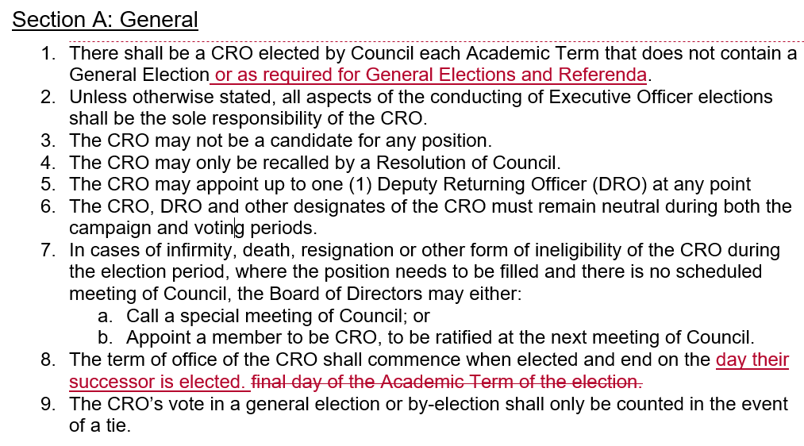
BIFRT | Bylaw 2: Elections and Referenda, Chapter III be amended to read as follows:  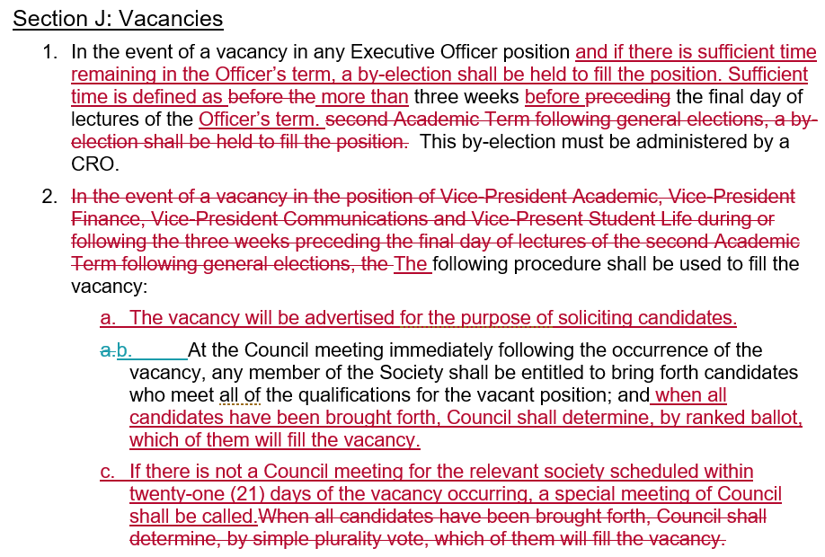  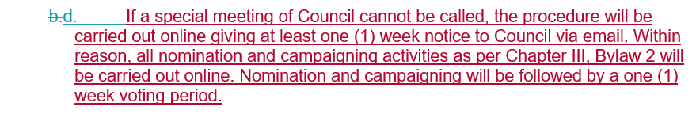
Against
Abstentions
Result | Passed to JAGM

Title | Point of Sale System for new RidgidWare
Mover | Liam Yeates
Seconder | Katie Arnold
Spirit | To provide $8000 for RidgidWare
WHEREAS | RidgidWare is moving to E7 upon completion
AND WHEREAS | We have entered into an agreement with the faculty and the SDC to increase RidgidWare stock and hours of operations in order to benefit more engineering students
AND WHEREAS | This requires and new Point of Sale because the current square system is inadequate
BIRT: | That the Engineering Society will buy one Point of Sale System for $8000
BIFRT: | That Engineering A-Society will provide $4000 and Engineering B-Society will provide $4000, from the Societies’ Surplus
Against
Abstentions | Kris
Result | Passed to JAGM

